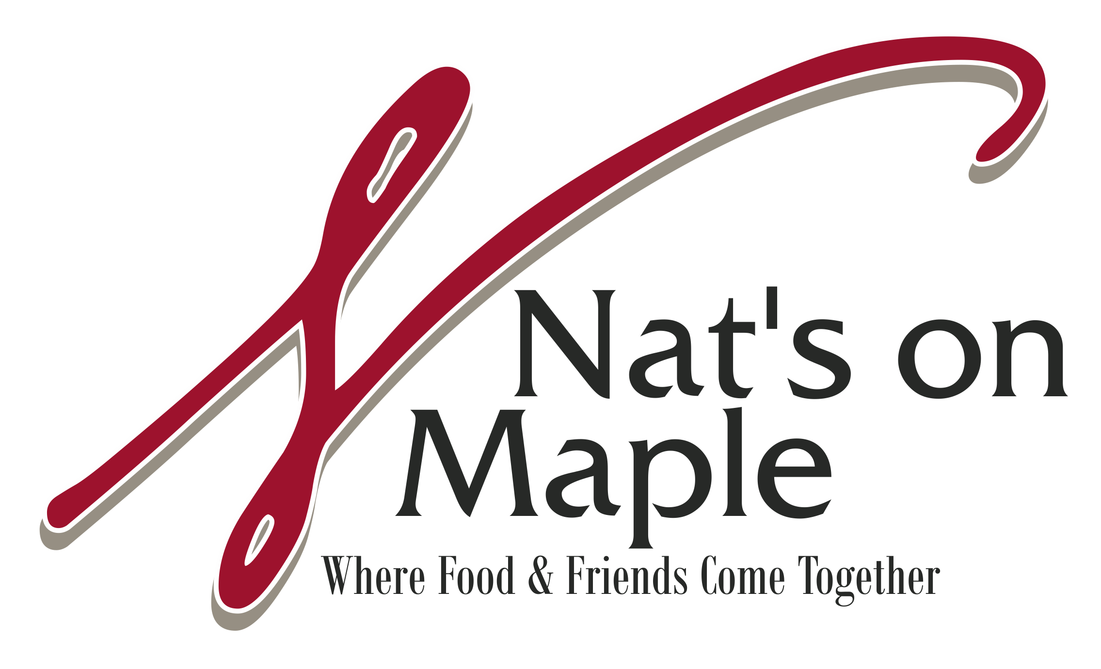

WEDDINGS
Few things beat the pleasure of entertaining a group of friends or family, enjoying food, drink and lively conversation. A wedding is one of the most memorable events in a person’s life. Nat’s on Maple would like to be the ones to help create that lifetime memory.

We want you, as the host, to enjoy your guests and take the worry and effort out of orchestrating your event. We have designed our menus to give you a taste of what we offer. Please meet w/ us personally to discuss substitutions and tailored menus.

WEDDING PACKAGES

STEP ONE
Select the style of service you prefer:

Plated
Buffet-Style
Family-Style
(additional $5pp charge for family-style)

STEP TWO
Select two entrees from the following menus

Silver (buffet only) $35.95
Gold $45.95
Platinum $55.95

STEP THREE
Select a salad, starch and vegetable

STEP FOUR
Join us for a personal consultation at Nat’s on Maple. We will assist you in creating your perfect menu and determining your service and rental requirements.

STEP FIVE
We welcome you to an exclusive tasting of your menu selections.

**all prices are subject to change

All Menus Include:
- Bride and Groom’s meal
- China plate ware and silverware for food
- White linen napkin for each place setting
- White linens for Buffet Table
- Greenery for Buffet Table
- Cake Cutting (cake plates and forks or cake service provided for an additional charge)
- Rolls and butter

To Secure Our Services:
- Signed contract and $500 to secure the date
- 50% due 60 days prior to wedding
- Final balances due one day prior to wedding

About Our Services
- Servers provided ~ $200 for each server for a 4-hour event. Number of servers based on the individual wedding and style of service chosen. There are no additional gratuities added to the event.

SILVER MENU

Lasagna

Meat or Cheese Ravioli

Chicken Limón

Chicken Marsala
Lightly floured chicken breasts sautéed with mushrooms topped off with a Marsala wine reduction.

Chicken with sundried tomato, spinach and a Parmesan cream sauce

Chicken with a basil parmesan cream sauce

Mesquite Chicken
Grilled Chicken with mesquite seasoning, mozzarella cheese and Cajun cream sauce.

Sliced Roast Beef

Roasted Pork

GOLD MENU

Chicken Madeira
Sautéed chicken breasts topped with, mushrooms and mozzarella cheese with a Madeira wine sauce

Chicken Piccata

Chicken with sundried tomato, spinach and a Parmesan cream sauce

Chicken with a basil parmesan cream sauce

Sliced Roast Beef

Blackened Salmon with a Florentine sauce

Herb Encrusted Pork Loin

Roasted Pork Loin with a Cherry Demi-glace

PLATINUM MENU

Chicken Oscar
Sautéed chicken breasts topped off with crab meat, mozzarella cheese and a lemon butter sauce

Prosciutto Parma Chicken and Asparagus
with a white wine garlic sauce

Roasted Pork Loin with a Cherry Demi-glace

Filet Mignon

Choice of sauces for your filet:
Wild mushroom
Shallot reduction
Garlic herb butter
Cabernet wine reduction

Beef Medallions with Cabernet reduction

Crab Stuffed Shrimp

Veal Piccata

Mahi ~ Mahi
With Vera Cruz Sauce

SALAD SELECTIONS

Tossed Salad
Mixed greens with tomato, cucumber, red onion and croutons

Traditional Caesar Salad
Romaine lettuce, parmesan cheese and crouton, Caesar dressing

Maple Street Salad
Mixed greens, dried cranberries, pecans, and mandarin oranges, drizzled with a Balsamic Vinaigrette

STARCH SELECTIONS

Mashed Potatoes
Herb Roasted Potatoes
Parmesan Baby Potatoes

VEGETABLE SELECTIONS
Sugar Snap Peas
Green Beans Almondine
Green Beans w/ butter
Seasonal Blend
Asparagus~ add $5pp

**All of our chicken is lightly floured.

PASSED OR TABLE HORS D’OEUVRES
3- Selections $10-$12pp 4-Selections $13-$15pp

Shrimp Cocktail-~ Jumbo shrimp served chilled with a spicy cocktail sauce.

Meatballs-~ Meatballs served Swedish or BBQ style.

Sausage Stuffed Mushrooms

Bruschetta-~ Classic combination of fresh tomatoes, basil, garlic, olive oil, and balsamic vinegar, served with french bread toast points.

Caprese Skewers ~ Tomatoes, fresh mozzarella and basil drizzled with a balsamic glaze

Antipasto skewers ~ Genoa salami, tomato, fresh mozzarella and artichoke hearts marinated

Crudité-~ Beautiful presentation of assorted vegetables with ranch dip, assorted cheeses and crackers, and seasonal fruit.

Chevre Crostini~ Toast points with Roasted Tomato, Goat Cheese and Fresh Basil

Beef Tips~ Beef tips complimented with a Cabernet Reduction

Citrus Shrimp~ Tender shrimp sautéed in a citrus sauce.

Bacon Wrapped Scallops

